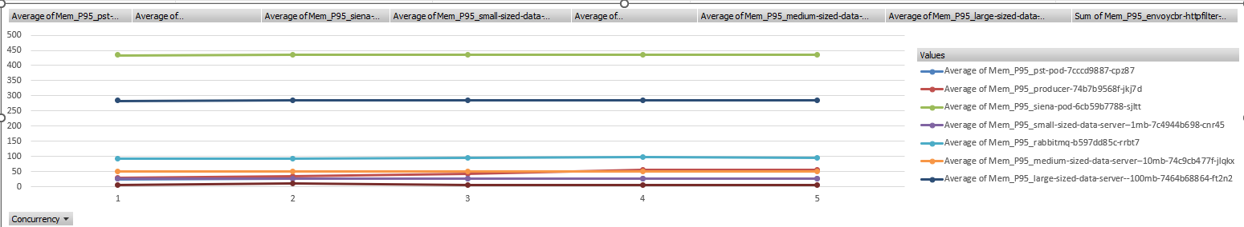

I realised that measuring the rate of change of data was important, rather than just the absolute volume of data as number of concurrent requests increases

